Chrome Extension Software Requirements (Easy Planner)

# Goals

* Create the best and easiest UI for the user to plan their day
* Add ability for a user to see the progress bar of their tasks in percentage.
* Have the user focus on a plan of action vs tasks for the day

# User Stories

As a <User>, I want <Goal> so that <some reason>

TASK: Complete User Stories for the rest of the functionalities in the app

* As a user, I want to see a list of all my plans of action items so that I can view them for the day.
* As a user, I want to add an action item so that I can continue adding to my plan of action for the day.
* As a user, I want to delete an action item so that I can remove any unnecessary item.
* As a user, I want to mark my items completed so that i can view action items that are completed.
* As a user, I want to see my progress in percentage.
* As a user, I want to add frequently used action items so that I can save time.
* As a user, I want to make easy bookmark button for website so that they can have easy access later when user wants to visit.
* As a user, I want to be greeted so that I can have a welcome user experience as I open up the app.
* As a user, I want to edit my name in the greeting so that i can be greeted with the correct name.

# Flow Diagram(Swimlane)

Shows who does what in the process (Example)

TASK: Complete Swimlane for adding a website as a task

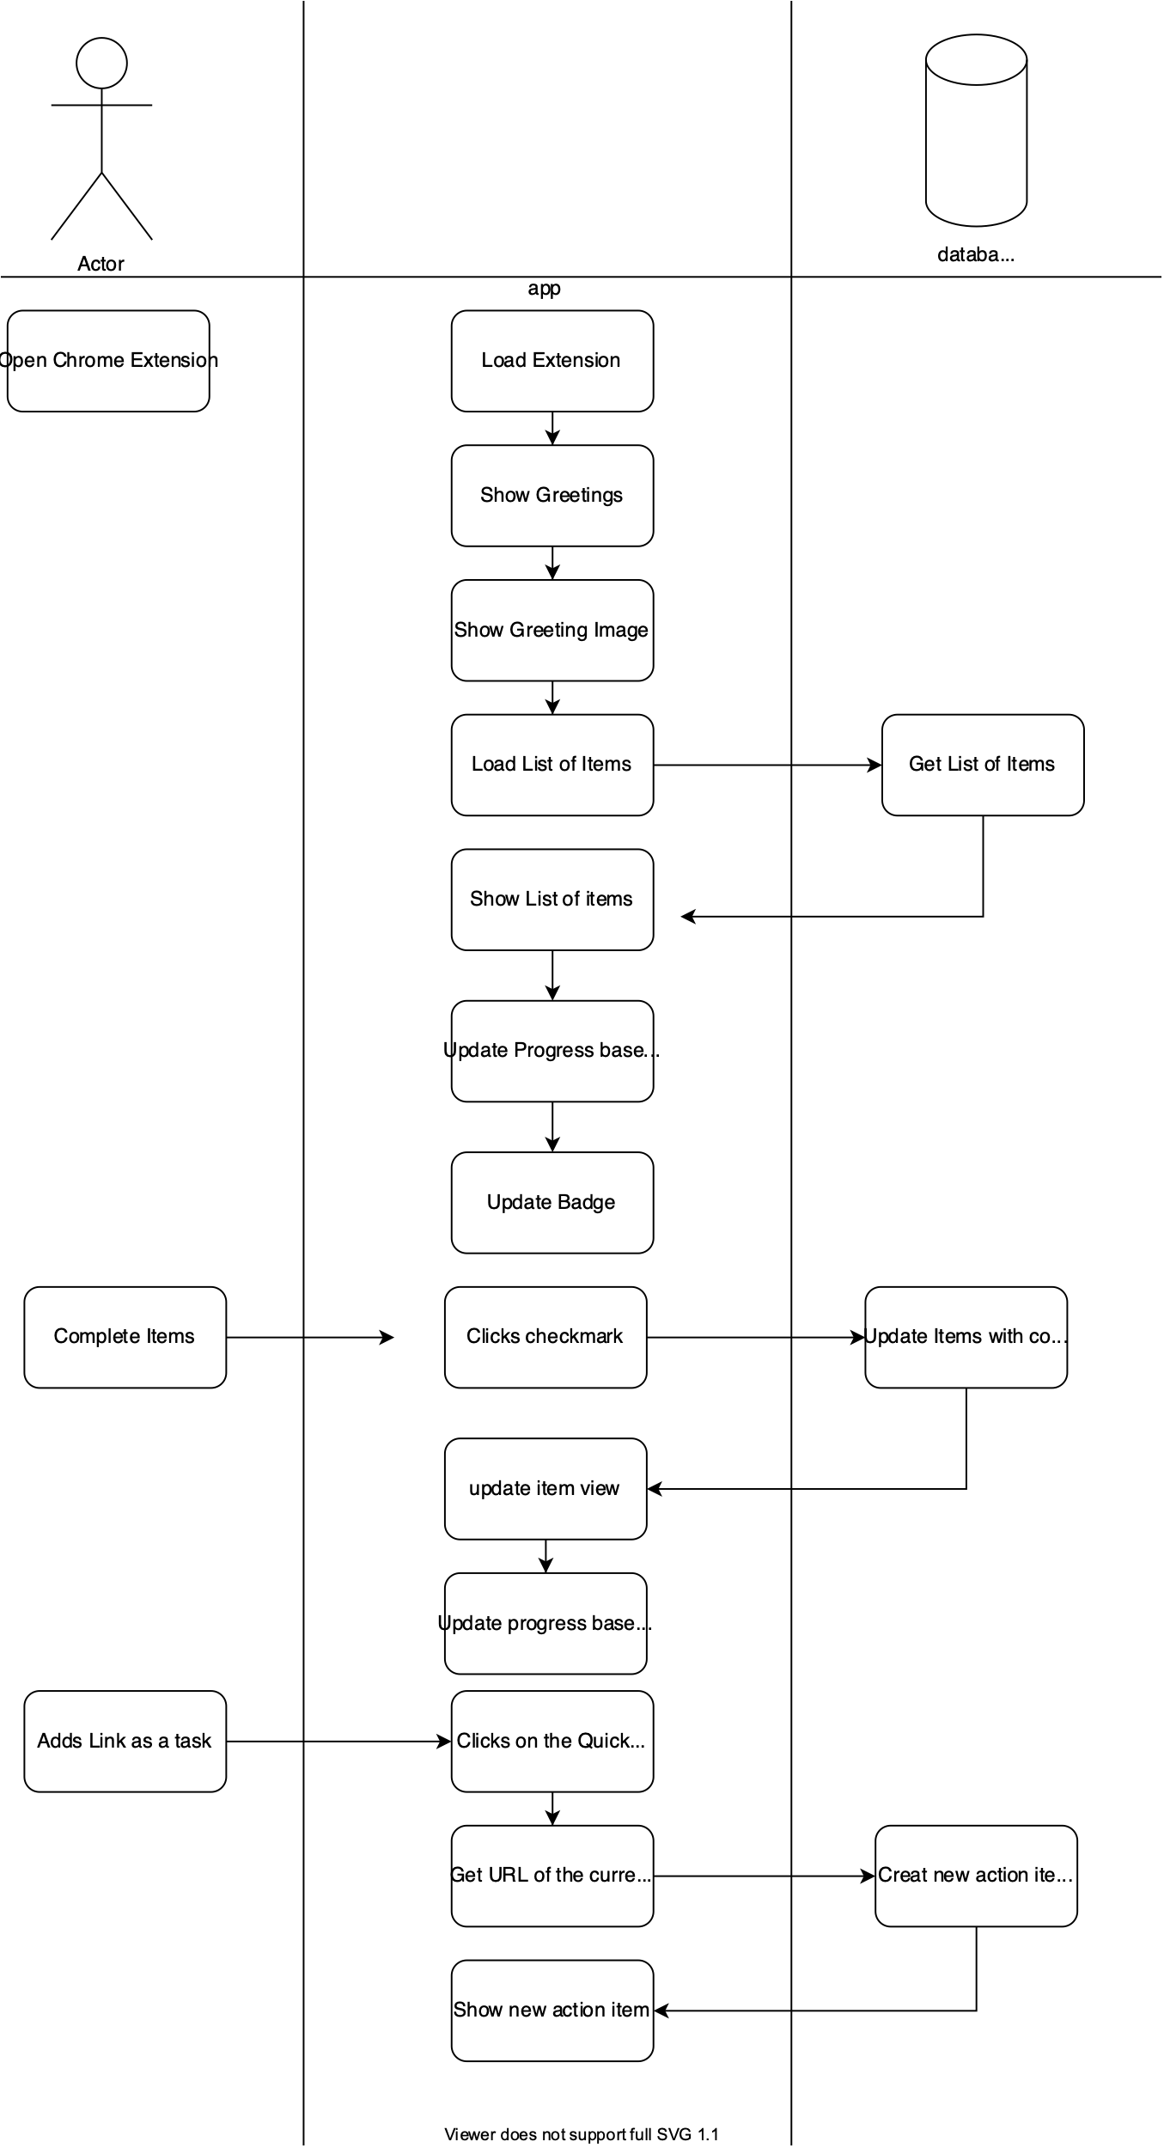

# Business Requirements

TASK: Complete Business Requirements for the Chrome Extension

# Technical Requirements

* Use Chrome Storage as a database to save data
  + <https://developers.chrome.com/extensions/storage>